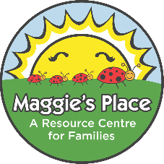

Parenting Journey Home Visitor
Maggie's Place Family Resource Centre (Cumberland)
Full-time, Permanent
(Internal & External Posting)
Amherst, NS

Maggie's Place is a family resource centre offering programs, information and support to families through the preconception, prenatal, infant, early childhood and youth periods, with an emphasis on the ages 0-6 early childhood period. We are seeking a highly motivated, self-directed individual to join our team.

Role:
Reporting to the Executive Director, the Parenting Journey Home Visitor is responsible for providing support to parents with children age three to nineteen years through home visiting and group programming (parent education, support groups, cooking programs) within Cumberland County.

Remuneration: $37,383-$43,134
Qualifications
- Post-secondary diploma in related discipline and/or equivalent education and experience.
- Experience working with families with young children/adolescents
- Demonstrated knowledge of child development and current parenting practices
- Group work experience and an ability to implement adult education principles
- Awareness of and sensitivity to participants’ social, cultural, and personal uniqueness
- Excellent organizational, communication & interpersonal skills
- Able to work effectively as a team member as well as independently
- Familiarity with government and community resources related to the needs of families
- A valid driver's license and access to a reliable vehicle
- Computer proficiency with Microsoft Office programs
- Willingness to be trained in CPR and First Aid, Child Passenger Safety, and Food Handlers

Closing Date: October 20th at 3:00pm

Email Cover Letter & Resume to: sarah@maggiesplace.ca
Sarah MacMaster, Executive Director

Thank you for your interest in this position.
Only those applicants selected for an interview will be contacted.

