Are you working in the Forestry Sector and have an interest in the skilled trades?
We are here to help.

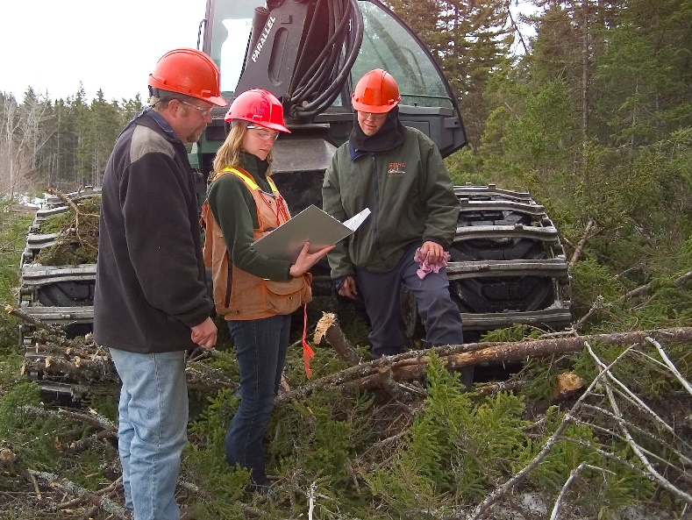

The Forestry Sector Apprenticeship Initiative, a partnership between the Nova Scotia Apprenticeship Agency and the Nova Scotia Community College, successfully supports workers’ and the province’s priority to facilitate a more sustainable forestry industry. Through available supports and a customized learning plan, individuals currently working in the sector will have the opportunity to develop the skills they need to advance in the sector or transition to a new sector, at no cost.
This initiative may be for you if you are:
- an existing apprentice who needs to connect with other employment opportunities;
- a skilled tradesperson who is interested in achieving trade certification; or
- a forestry sector worker without prior experience who is interested in pursuing a skilled trade.
If you or someone you know may be a potential candidate for these supports, please go to:
https://novascotia.ca/lae/apprenticeship/ForestryInitiative.aspx to apply
or
contact our office at 1-800-494-5651 and a Program Advisor will assist you.

