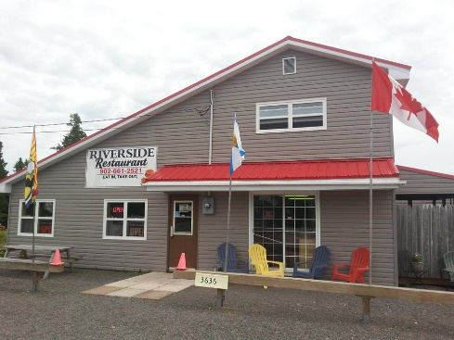

Riverside Restaurant – Tidnish, NS

Job Title: Cook
Salary: Negotiable
Hours: 30 – 40 per week
Responsibilities:
- Food preparation including washing, peeling, cleaning, dicing
- Preparation of top-quality meals for customers
- Following instruction and attention to detail
- Cleaning kitchen area daily and as needed
- Making sure supplies are adequately stocked
Skills & Qualifications: Previous cook experience is preferred, but not necessary. Employer is willing to train the right individual who is a team player and is willing to take direction. Must have or be willing to complete food safe training.
This is a great seasonal opportunity for the right individual who wants to work in a well- established family owned business.
How to apply: If interested please apply in person to Riverside Restaurant, 3636 Highway 366 Tidnish Bridge, NS or via email at wcpugsley1@hotmail.com

