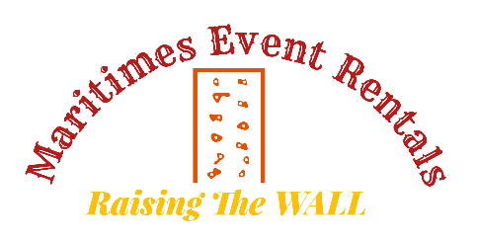

Job Ad
Employer: Maritimes Event Rentals
Job Title: Labour and Equipment Set Up Worker
Hours: Part Time / Seasonal
Salary: Negotiable
We are looking for an employee to join our team. Must be willing to travel, work weekends and some weekdays. Work includes the set-up of equipment including inflatables for party events, rock walls, etc. Must be able to lift, pound stakes, clean equipment, work around children and learn on the job.
Please apply via email to maritimeseventsrentals@gmail.com

