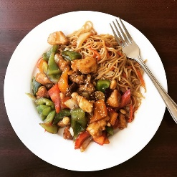

-Job Ad-
Gourmet Dumplings Original Chinese Cuisine – Waiter/Waitress Part Time Position
We are looking for an energetic, friendly person, preferably a non-smoker, who would like to work our waitstaff position over lunchtime. Shifts will be from 11:00 am to 1:00 pm Monday to Friday.
Responsibilities include helping with food preparation, cleaning, resetting tables, serving customers and cashier duties.
Wage is 11.55$ per hour
Please apply in person with resume to:
Gourmet Dumplings Original Chinese Cuisine
9 Laplanche Street Amherst NS

