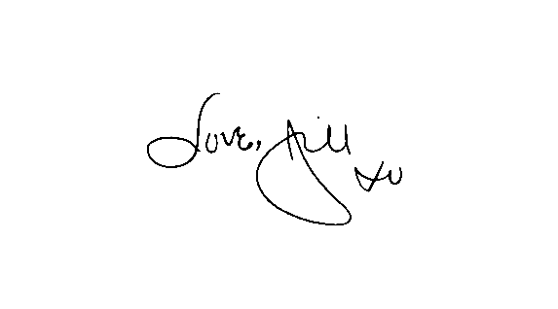
Construction Carpenter/General Maintenance Worker
3227041 NS LTD O/A Love, Jill Boutique and Blackrock Bistro is seeking a skilled Construction Carpenter/General Maintenance Worker that can take direction well and is wanting to pursue employment within the field of carpentry. Working location is Parrsboro.
The ideal candidate will:
Have the ability to show up on time.
Have a reliable means of transportation
Have a working cell phone
Have an Excellent Work Ethic.
Maintain a Positive, upbeat attitude.
Be a motivated self starter.
Have a minimum of 2 years construction experience.
Have a valid NS driver’s license
Have the ability to work without close supervision.
Must be able to perform manual labour under adverse weather conditions.
Full knowledge of construction materials, tools, machinery and processes.
Have excellent communication skills.
Open to criminal record check.
Safety Credentials an asset (WHMIS, Fall Arrest, Asbestos Awareness)
Must have own basic hand tools
Job Type: Full-time
Salary: TBD
Experience: Skilled Labor: 1 year (Preferred)
Licence: Driver's licence
Interested individuals can apply via email at lovejill.cindy@gmail.com

