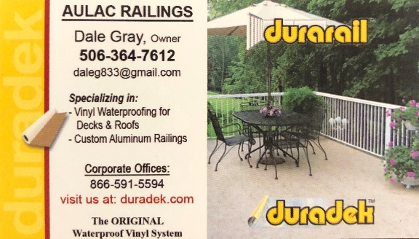

Aulac Railings – Installation Assistant
We are looking for 2 Installation Assistants to join our growing business! Installing railings, waterproofing of decks and roofs is our passion.
Salary: 15$ an hour to be negotiated
Hours: 30 to 40
Responsibilities include: Preparing sheets, preparing decking, sanding, inspections and seam welding. Must be physically fit, able to stand and crouch for extended periods, able to lift heavy materials and able to work in an outdoor environment. We will provide training for the right individuals who are driven and have a passion for providing great quality service.
Please send resumes to daleg833@gmail.com or call 506-364-7612 for serious inquires only.

