The Business Support: Information, Focus, Clarification & Opportunities Breakfast
Friday, April 13, 2018 8:30 am to 10:30 am
Community Credit Union Business Innovation Centre

5 Ratchford St.,
Amherst, NS.

Where Representatives of:
- Labour & Advanced Education
- Nova Scotia Works
- Community Business Development Corporation,
- Nova Scotia Business Inc.
- Business Canada / ACOA
- Immigrant Services Association of Nova Scotia, and the
- Cumberland Business Connector
…will be highlighting what they can do to support Nova Scotia businesses.
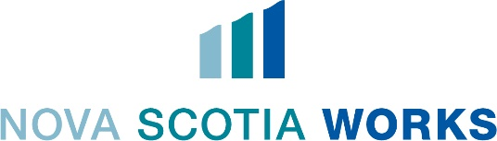
Following the information presentations, the speakers will be available to answer your specific questions on a one-on-one basis.

No Cost but RSVP required: Register by any ONE of:
On-line at www.amherstchamberns.ca events, or by direct link HERE,
Amherst & Area Chamber of Commerce at info@amherstchamberns.ca or 902-667-8186 or
Barry Patriquin at barry.patriquin@cansa.ca or 902-661-1509 ext.231

