NOW HIRING! In Parrsboro, NS!
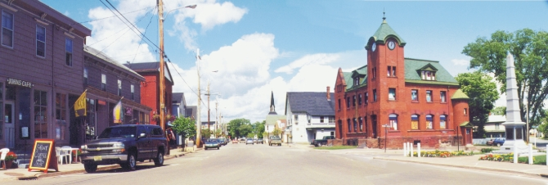
McLeod Safety Services and Supplies is a leading safety services and supply company, specializing in traffic control, safety supplies and signs, and training, with over 25 years of experience in the industry.
We are currently looking to hire traffic control personnel who are safety conscious, professional, have a positive attitude and strong work ethic, to join our growing company.
We need 3-4 new employees in the Parrsboro area. If you are looking for year round, full time work with steady hours, opportunities to progress with the company, one of these new hires could be you!
We offer $11.00/hour to start, full benefits (health and dental) to employees and their immediate family, professional uniforms, a safe work environment to name just a few benefits.
Apply today!
Please call 902-893-3015! Email jrichard@mcleodsafety.ca or visit our website www.mcleodsafety.com/careers

McLeod Safety McLeod Safety McLeod Safety McLeod Safety
902-893-3015 902-893-3015 902-893-3015 902-893-3015
jrichard@mcleodsafety jrichard@mcleodsafety jrichard@mcleodsafety jrichard@mcleodsafety.ca

